Summary HW7

Validate test condition

- Concurrent user (50 users)

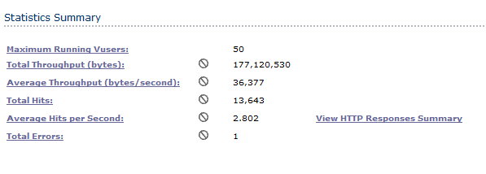

- Estimated number of transactions on peak hour

|  |  |  |  |
| --- | --- | --- | --- |
|  | Minimum | Maximum | Result |
| Agent | 150 | 200 | 182 |
| Customer service | 250 | 300 | 303 |
| Customer | 20 | 30 | 28 |

Validate test condition (Concurrent user and Estimated number of transactions on peak hour) pass because Concurrent user ran 50 users. Agent and customer ‘s transaction response time following the requirements except result of customer service was more than requirement.

Validate test criteria

Transaction Response Time

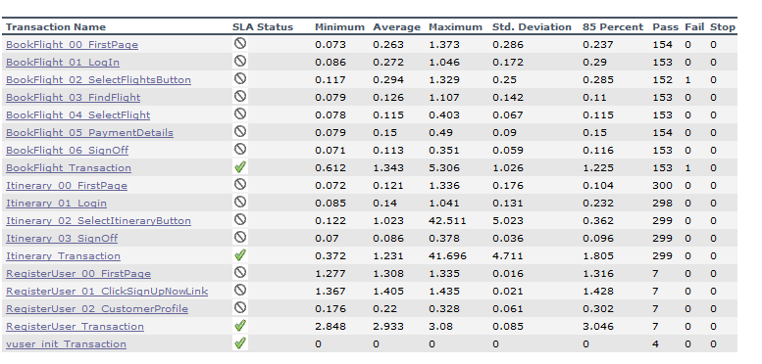

Validate test criteria (Transaction Response Time) pass because Transaction Response Time have following the requirements (85% of less than 5 Secord).

Transaction summary

Agent 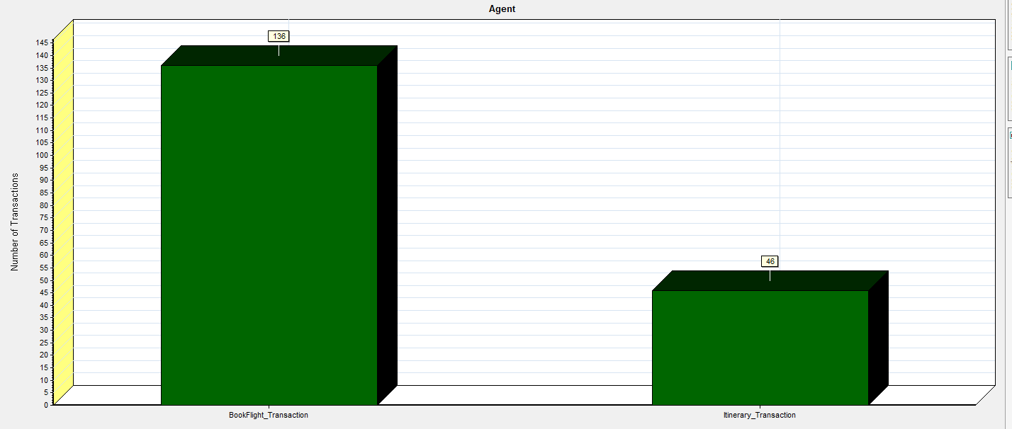

|  |  |  |
| --- | --- | --- |
| transactions | pass | fall |
| Bookflight | 136 | - |
| itinerary | 46 | - |

Customer service

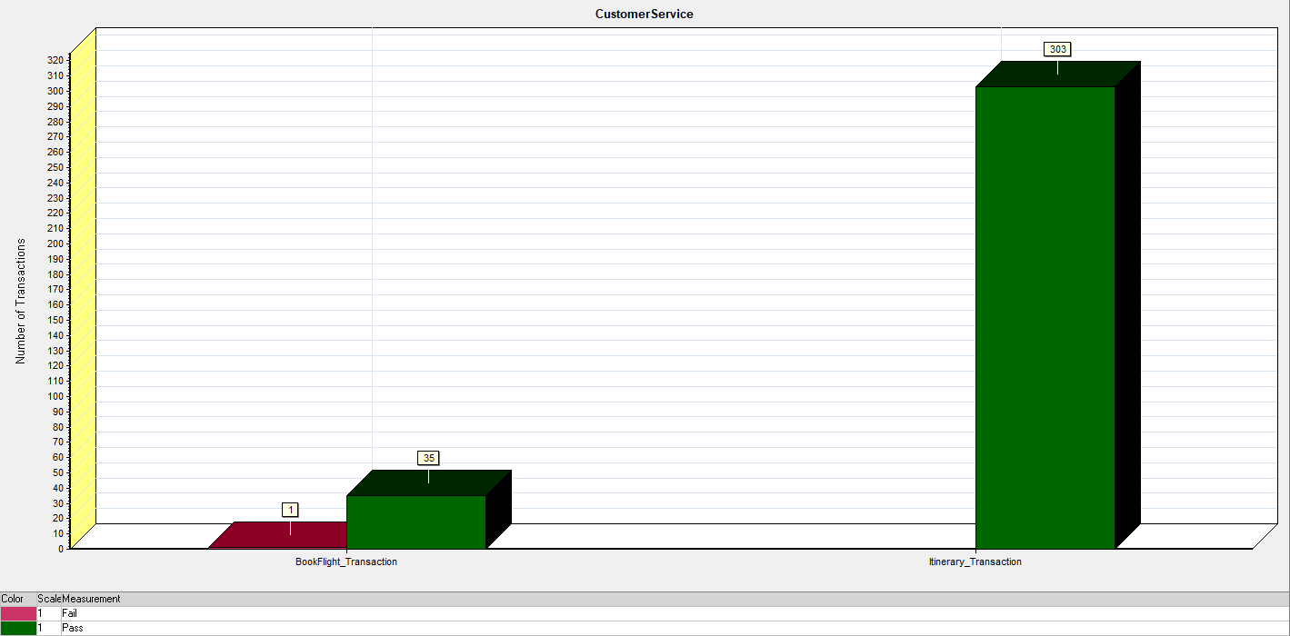

|  |  |  |
| --- | --- | --- |
| transactions | pass | fall |
| Bookflight | 35 | 1 |
| Itinerary | 303 | - |

Customer

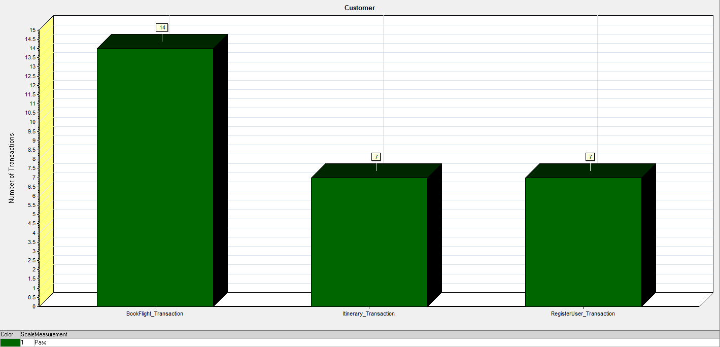

|  |  |  |
| --- | --- | --- |
| transactions | pass | fall |
| Bookflight | 14 | - |
| Itinerary | 7 | - |
| Regiteruser | 7 | - |

Validate test criteria (Transaction summary) pass because pass 548 translations and fail 1 translation (Bookflight (Customer service) I think have bug in testing)

Resource utilization (on server process)

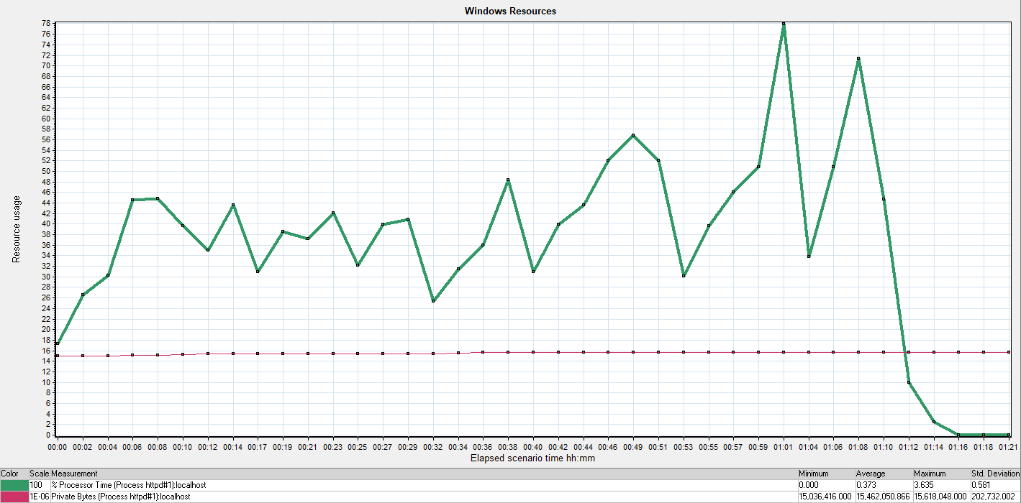

|  |  |  |  |
| --- | --- | --- | --- |
| Measurement | Minimum | Average | Maximum |
| Private byte(memory) | 15.036 | 15.462 | 15.618 |
| % processor Time (CPU) | 0.000 | 0.373 | 3.635 |

|  |  |  |
| --- | --- | --- |
|  | Requirement | Result |
| CPU | Less than 30 % | 0.373 |
| Memory | Less than 10 % of total memory | 15.462 |

Validate test criteria (Resource utilization) pass only CPU because memory use 15.462% (not pass) (using Ram 8 GB = 1.23696) and CPU 0.373 % (pass) have achieved criteria (memory 10 % and CPU 30%). we should scale up memory or allocation memory in software.

Tianwit Moungnoycharoen 61130500214